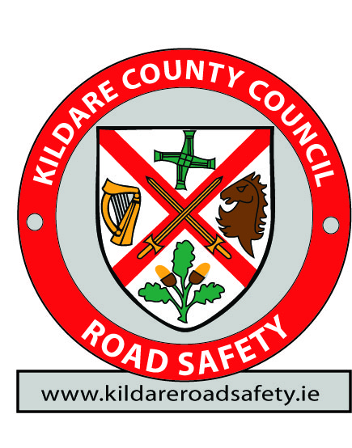
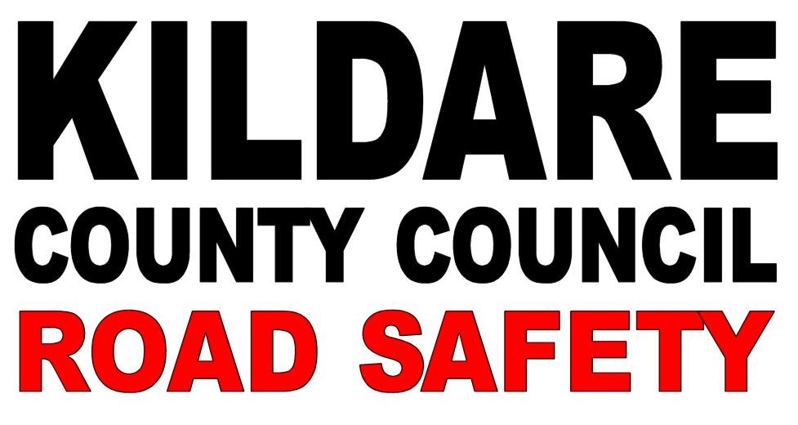

Form KRS_Expo_YR_CG1

‘Kildare Road Safety’
‘Safety Awareness Info Expo’
Punchestown Event Centre, Co. Kildare.
11th December 2014
Youth & Community Group Attendance Form

Group Name
Address
Town |  |  |  |  | County
Supervisors Name
Coordinator’s Name
Coordinator’s Mobile
E-mail Address
This group WILL attend the Road Safety Expo on Thursday December 11th 2014. |  | YES | NO | Reason for Not Attending…
Across, please indicate:  Group Type,  Group Numbers and  Numbers Male or Female | Year Type |  | Y / N | Total |  | Male |  | Female
 | Youth Reach
 | Youth Group
 | Foroige
 | Macra na Feirme
Please indicate if you require any disabled access.

GROUPS SOCIAL MEDIA DETAILS:
Website
Facebook Address
Twitter handle and Name

IMPORTANT NOTICE
COMPLETED FORMS SHOULD BE RETURNED via email to: roadsafety@kildarecoco.ie or post to:
Declan Keogh, Road Safety Officer, Kildare County Council, Áras Chill Dara, Naas, Co. Kildare.

